Business Interpretation Summary
Online Retail Customer Segmentation with K-Means, DBSCAN, Hierarchical Clustering and Business Rules
Scope: Covers all five Learning Day 8 notebooks and the official MVD checklist for clustering with K-Means, DBSCAN, Ward hierarchical clustering and Gap Statistic.

1. Executive business view
This project turns Online Retail transaction data into customer segments that business teams can actually use. The final recommendation is to use K-Means k=5 as the main segmentation baseline, DBSCAN as an unusual-customer detection layer, and constraint-based rules to convert clusters into more actionable business groups.
Final recommendation: Use K-Means k=5 for the main segmentation, DBSCAN for unusual customers, and business-rule labels for VIP and reactivation logic.

Result | Value | Business meaning
Customers analysed | 4,312 | Customer-level RFM table after cleaning and feature engineering
PCA visual coverage | 88.96% | PC1 + PC2 explain most scaled RFM structure for visual maps
K-Means baseline | k=5, Silhouette 0.6140 | Main clean segmentation baseline
Strong outliers | 311 customers | Outliers identified using multiple rules / detectors
DBSCAN practical result | eps=0.5, min_samples=5, 3 clusters, 63 noise customers | Useful density and unusual-customer layer
OPTICS result | 12 clusters, 1,826 noise customers, Silhouette 0.1888 | Exploration only; too strict for final segmentation
Hierarchical result | Ward k=3, Silhouette 0.5752 | Dendrogram-supported practical cluster view
MVD coverage | 14/14 tasks covered | Beginner, Intermediate and Expert requirements completed

2. Customer segmentation story
The customer base contains a large normal group, inactive low-frequency buyers, and very small but highly valuable outlier/VIP-style groups. This is why one model alone is not enough. K-Means creates the broad segmentation; outlier detection and DBSCAN keep unusual customers visible instead of forcing them into normal groups.
K-Means cluster | Customers | Avg Recency | Avg Frequency | Avg Monetary | Revenue Share | Business reading
0 | 208 | 16.77 | 21.76 | 12,210.23 | 28.87% | Very valuable active/outlier-heavy customers
1 | 3,053 | 44.70 | 3.77 | 1,370.06 | 47.54% | Main customer base
2 | 10 | 3.70 | 118.10 | 66,250.55 | 7.53% | Tiny high-frequency high-value group
3 | 3 | 6.00 | 89.67 | 264,703.53 | 9.03% | Extremely high-value VIP-style group
4 | 1,038 | 243.86 | 1.66 | 596.43 | 7.04% | Inactive / low-frequency customer group

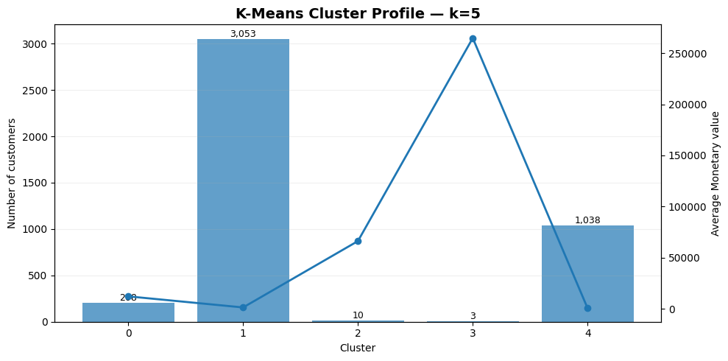
K-Means k=5 cluster profile: customer count and average monetary value.

3. Recommended customer actions
Business group | Where found | Evidence | Recommended action
Main customer base | K-Means cluster 1 | 3,053 customers; stable revenue share | Standard retention, cross-sell and product recommendation campaigns
Inactive/low frequency group | K-Means cluster 4 plus constraint rules | High recency and low frequency | Win-back campaigns, reactivation offers and churn-risk monitoring
High-value active group | K-Means cluster 0 | Small group with high revenue share and strong outlier concentration | VIP service, account management and margin monitoring
Extreme VIP outliers | K-Means clusters 2 and 3 / DBSCAN noise | Very small groups with very high monetary value | Manual review, VIP treatment and fraud/wholesale check if needed
Unusual customers | DBSCAN noise customers | 63 customers; 1.46% of customers but high revenue share | Do not hide them inside normal clusters; review separately

4. Why K-Means remains the main baseline
DBSCAN produced a slightly higher Silhouette score than K-Means in the practical density run, but it created only dense groups and noise labels. That is excellent for unusual-customer detection, but less convenient for everyday campaign segmentation. K-Means is simpler, stable and easier to explain.
Method | Clusters | Noise customers | Silhouette | Davies-Bouldin | Calinski-Harabasz | Best use
K-Means k=5 | 5 | 0 | 0.6140 | 0.6304 | 4006.5535 | Main segmentation baseline
DBSCAN | 3 | 63 | 0.6259 | 0.3119 | 68.1318 | Unusual customer detection layer
Hierarchical Ward k=3 | 3 | 0 | 0.5752 | 0.5914 | 3149.7195 | Supporting hierarchy view

5. Business limitations and next steps
- RFM segmentation is based on historical purchase behaviour; it does not directly include marketing channel, customer acquisition source or product margin.
- Very high-value outliers may represent VIP customers, wholesale buyers, unusual invoices or data quality cases. They should be reviewed before business action.
- Cluster names should be finalized with business stakeholders before being used in dashboards or campaigns.
- A Power BI or Looker Studio dashboard can convert the final segment tables into a management-ready view.
- Future improvement: add churn labels, campaign response, profitability, product category affinity and customer lifetime value modelling.

6. Dashboard handoff view
Dashboard area | What to show | Why it matters
Main KPI cards | Customers, revenue, average monetary value, recency risk, noise customers | Gives management a fast overview of segment health
Segment filter | K-Means cluster, DBSCAN noise flag, constraint segment | Lets users move between model and business views
Customer action table | CustomerID, segment, monetary value, frequency, recency, country | Supports campaign export and sales review
VIP / outlier review | High monetary customers and DBSCAN noise customers | Prevents valuable unusual customers from being hidden
Reactivation view | Inactive low-frequency customers | Creates a clear win-back target group

Business close: The project is ready to support a management dashboard, campaign segmentation file, or final course submission package.

